CENTRAL HIGH SCHOOL KASANJE
END OF YEAR EXAMINATION 2023
S2 BIOLOGY
1½ hours.
Attempt all questions.
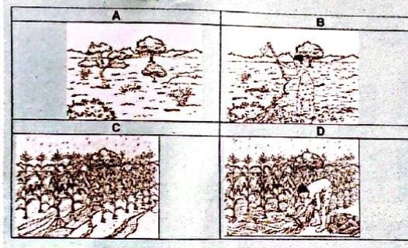
1. The following figure shows images obtained during research to document the farming habits of a farmer in a rural village in Uganda.

Task.
Discuss how you would use the images to address a group of p7 pupils about soil erosion and conservation.


2. Abigail a 13 year old girl is a student who is very active and likes doing physical exercise every morning. She has recently been added to the school junior netball team. Her mother back home is five months pregnant and takes care of her 80 year old grandfather. Abigail's father works at the supermarket in the area as an attendant. The family has been having issues over which food to prepare that will suit the needs of each family member. You have been contacted as a nutritionist to save the situation in the family.

Task. As a nutrition expert, design a food menu for each individual in the family including its rationale/use.

